

May should provide us with some of the best fishing conditions and in turn some of the best landings so far this year.

The ‘King of the Sea’ Wild Turbot will be readily available as the season kicks in and we can hopefully benefit from a drop in the eye watering prices they have been fetching on Brixham, Newlyn and Plymouth.

News from the Seafood Expo in Barcelona was mixed. We should see salmon begin a slow decline in price but codling and haddock are predicted to become difficult for the rest of 2023.

As lobster fishing areas in Atlantic Canada open we will see the prices of both import and native lobsters drop.

We can also (optimistically) look forward to the beds reopening around Dorset bringing the price of Palourde Clams back down.

**MAY 2023**

**INGREDIENTS – Escabeche Marinade**

2 Courgettes – canoli sliced  
½ Litre OJ reduced  
2 Chillies  
2 Tspn toasted fennel seed  
Thyme  
Bayleaf

Salt and pepper

Lemon juice to taste

To go with your choice of oily fish such as **Mackerel** or **Salmon**

10 Carrots – canoli sliced  
2 Aubergines skins - diced  
4 Shallots – diced

4 Shallots - ringed

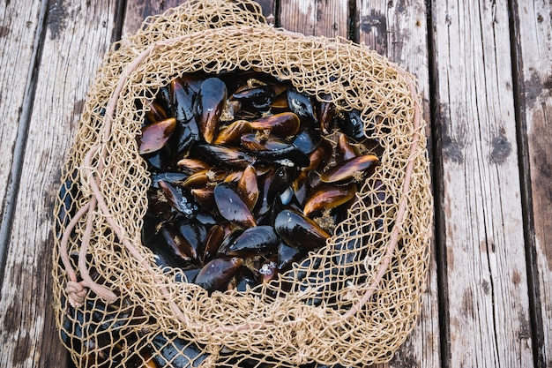

**METHOD**

1. Prep ingredients as per instructions above
2. Bring all to the boil in the orange juice
3. Leave to chill for 24 hours in the fridge





A premium fish such as **Wild Turbot** should be finding its way onto menus up and down the country.

**Wild Bass** season is back in full swing, buy at the right time and these fish can provide excellent value for such a popular fish!

* **Loch Duart Salmon** made the menu for the Downing Street Coronation Celebrations
* **Cephalopods –** Smaller landings and higher demand across several markets is not good news for those with **Octopus** on their menu